Patient Access to Medical Records Policy
Version 3.0
Turner Martin (Mr)
28 September 2020
A. Confidentiality Notice
Confidentiality Notice. This document and the information contained therein is the property of Staveleigh Medical Centre. This document contains information that is privileged, confidential or otherwise protected from disclosure. It must not be used by, or its contents reproduced or otherwise copied or disclosed without the prior consent in writing from Staveleigh Medical Centre.

B. Contents
C. | Document Details | 1
D. | Document Revision & Approval history | 1
E. | Definitions | 1
F. | Persons Whom Policy Applies to | 2
G. | Responsible Office | 2
H. | Introduction | 2
I. | Practice Statement | 2
J. | Operational Implementation & Procedures | 2
K. | Statement Publication | 6
L. | Additional Information | 6
M. | References & Further Resources | 6
N. | Appendices | 6

C. Document Details

Classification: | Policy
Author and Role: | Mr Martin Turner, Practice Manager
Organisation: | Staveleigh Medical Centre
Document Reference: | Patient Access to Medical Records Policy_V.3.0
Current Version Number: | 3.0
Current Document Approved By:
Date Approved: | 28 September 2020

D. Document Revision & Approval History

Version | Date | Version Created By | Version Approved By | Comments
1.0 | March 14 | Mrs D Teasdale | Dr S Ul-Haq
1.1 | April 18 | Mrs D Teasdale | Dr J Shilhan
2.0 | June 19 | Mrs D Teasdale |  | Added our own online access information
3.0 | Sept 20 | Mr M Turner |  | Formatting.

E. Definitions
“The Practice”, “We” | On behalf of The Partners of Staveleigh Medical Centre
“CCG” | Clinical Commissioning Group for Tameside and Glossop
“Office”, “Officers” | Responsible persons for policy

F. Persons Whom Policy Applies to
Staff, faculties, visitors, stakeholders and other persons or bodies affected by or for whom this policy applies to:
- All Clinical staff.
- Patients.
- 3rd Party Staff.
- All Stakeholders.

G. Responsible Office
Office or officers charged with developing, updating, communicating, training, ensuring compliance with, and providing resources to promote adherence to this issued policy:
- Practice Manager.
- All Practice Staff.
- Practice Partners.

H. Introduction

The law states that NHS organisations must, when requested, for personal information (for living individuals), be given access to their personal health information, and occasionally, certain relevant information pertaining to others. In order to do this, they must have procedures in-place that allow for easy retrieval and assimilation of this information.

I. Practice Statement

Staveleigh Medical Centre is committed to training staff to act efficiently and calmly in emergency incident situations.

J. Operational Implementation and Procedures
The main areas of legislation that allow the right of the individual to request such personal information, and they are:

- The Data Protection Act 1998
- The Access to Health Records Act 1990
- The Medical Reports Act 1988
- GDPR 2018

Where the request for information by an individual falls under the legislation of any of these areas, access must be granted. Patients requesting information about their own personal medical records would usually have their request dealt with under the provisions of the Data Protection Act 1998.

What Constitutes a Health Record?

A health record could include, and not exhaustively, hand-written clinical notes, letters between clinicians, lab reports, radiographs and imaging, videos, tape-recordings, photographs and monitoring printouts. Records can be held in either manual or computerised formats.

Patient Access to Medical Records Policy

The Data Protection Act 1998

This scope of this Act includes the right of patients to request information on their own medical records. Requests for information under this Act must:

- As Calidicott Lead, Dr John Doldon at STAVELEIGH MEDICAL CENTRE has executive responsibility for Subject Access requests and monitors all subject access requests to ensure the correct process has been followed and monitors any appeals or complaints relating to subject access. The data Protection Officer has operational responsibility for Subject Access Requests. All staff must be aware of how to recognise and manage a subject access request. Training will be provided to staff likely to be in receipt of requests covering:-
- E-mail requests are allowed or via online access. Verbal requests can be accepted where the individual is unable to put the request in writing – this must be noted on the patient record;
- Be accompanied with sufficient proof of identity to satisfy the GP and to enable them to locate the correct information (where requests are made on behalf of another, the data controller must satisfy themselves that correct and adequate consent has been given);

The data controller should check whether all the individual’s health record information is required or just certain aspects.

Where an information request has been previously fulfilled, the data controller does not have to honour the same request again unless a reasonable time-period has elapsed. It is up to the data controller to ascertain what constitutes as reasonable.
Requests for health records information should be recorded internally and fulfilled within 30 days (unless under exceptional circumstances – the applicant must be informed where a longer period is required). Information given should be in a manner that is intelligible to the individual.

Which clinician should be consulted for information?

The correct clinician to be consulted about an individual’s information should be:
- The clinician who is currently, or was most recently, responsible for the clinical care of the individual in connection with the information which is the subject of the request; or
- where there is more than one such clinician, the one who is the most suitable to advise on the information which is the subject of the request.

Fees and response time

Under GDPR the practice must provide information free of charge. However, we can charge a reasonable fee when a request is manifestly unfounded or excessive, particularly if it’s repetitive.

The fee must be based on the administrative cost of providing the information only.

Requests for Insurance Purposes

Insurance companies may contact the practice to request a patient’s full medical records through the use of Subject Access Requests (SAR) under the Data Protection Act 1998. On the advice of ICO, the BMA advises that upon receiving a SAR from an insurance company, practices should get in contact with the patient to explain the implications of such a request and the extent of the disclosure. The ICO also makes it clear that GPs should provide the SAR information directly to the patient themselves, rather than sending it to the insurance company.

The ICO’s Subject Access Code of Practice states that ‘If you think an individual may not understand what information would be disclosed to a third party who has made a SAR on their behalf, you may send the response directly to the individual rather than to the third party. The individual may then choose to share the information with the third party after having had a chance to review it.’

It is expected that insurance companies will stop requesting SARs and instead revert to requesting medical reports. Practices are able to apply a fee for completion of these reports, in line with the work associated, and should seek to agree the fee with the requestor in advance of completion.

Denial or Limitation of Information

The data controller may deny or limit the scope of information given where it may fall under any of the following:

- The information released may cause serious harm to the physical or mental health or condition of the individual or any other person, or
- The disclosure would also reveal information relating to or provided by a third person who has not consented to that disclosure unless:

- The third party is a clinician who has compiled or contributed to the health records or who has been involved in the care of the individual;
- The third party, who is not a clinician, gives their consent to the disclosure of that information;
- It is reasonable to disclose the information without that third party’s consent.

A reason for denial of information does not have to be given to the individual, but must be recorded.

Former NHS Patients Living Outside the UK

Patients no longer resident in the UK still have the same rights to access their information as those who still reside here, and must make their request for information in the same manner.
Original health records should not be given to an individual to take abroad with them, however, the Practice may be prepared to provide a summary of the treatment given whilst resident in the UK.

Parental Requests for Information pertaining to their Children

Children over the age of 11 are generally considered to have the capacity to give or withhold consent to release medical records, but those under 16 should demonstrate that they have the capacity to make these decisions.

Individuals with parental responsibility for an under 18 year old will have a right to request access to those medical records. Access may be granted if access is not contrary to the wishes of the competent child. Not all parents have parental responsibility - a person with parental responsibility is defined as either:

- the birth mother, or
- the birth father (if married to the mother at the time of child’s birth or subsequently) if both are on the birth certificate, or,
- an individual given parental responsibility by a court.

It is important to be aware that children under 16 who have capacity and understanding for decision-making should also have their confidence respected.

Complaints and Appeals.

STAVELEIGH MEDICAL CENTRE has procedures in place to enable complaints about access to health records requests to be addressed.

The following channels are used to field any complaints regarding the access of health records at the Practice:

- Firstly, the clinician involved should arrange to have an informal meeting with the individual to try to resolve the complaint locally;
- If the issue remains unresolved, the patient should be informed that they have a right to make a complaint through the NHS complaints procedure (further information is available at: http://www.nhs.uk/NHSEngland/thenhs/records/healthrecords/Pages/what_to_do.aspx

Sometimes the patient may not wish to make a complaint through the NHS Complaints Procedure and instead, take their complaint direct to the Information Commissioner’s Office (ICO) if they believe the Practice is not complying with their request in accordance with the Data Protection Act.

https://www.ico.org.uk/global/contact_us

Information Commissioners Office
Wycliffe House
Water Lane
Wilmslow
Cheshire
SK9 5AF
Telephone 0303 123 1113

Email casework@ico.gsi.gov.uk

Alternatively, the patient may wish to seek legal independent advice.

Online Access to Medical Records

It is a contractual obligation to allow patients to gain online access to coded information held in their medical records, including data on medication, allergies, illnesses, immunisations and test results. As of April 2014, practices have been obliged to offer patients the opportunity to view online information equating to a Summary Care Record (SCR).

Patients will need to register online with the practice to be able to gain access to this information. The following checks must be undertaken to ascertain the patient’s identity before they are able to access records:

- Checking photo ID and proof of address, for example, a passport or driving licence and a bank statement or council tax statement.

- If the patient has no ID but is well known to the surgery, a member of staff may be able to confirm their identity.

- If the patient has no ID and is not well known to the surgery, the ability to answer questions about the information in their GP record may confirm that the record is theirs. By providing evidence of ID with a bank card if the above details are checked and verified by the staff member.

GP software will be configured to offer all coded data by default, but GPs will be provided with the tools to withhold coded information where they judge it to be in the patient's interests or where reference is made to a third party.

It is permissible for the practice to offer patients online access to their comprehensive medical records. However, in some circumstances a GP may believe it is not in the best interests of the patient to share all information in the record, e.g. where it could cause harm to the patient’s physical or mental health, or in cases where it contains information about a third party.

The practice is only expected to meet the above requirements for patient online access to their record when they have been provided with the GPSoC-approved and funded IT systems. Staveleigh Medical Centre has this provision in place.

Coercion

Making services such as access to medical records available online carries with it the risk of users being subject to coercion. Patients may be vulnerable to being forced into sharing confidential information from their records against their will. Where this is believed to be a possibility, online access to medical records can be denied. This action should be discussed privately with the patient before a final decision over whether to deny access is taken.

As part of their request to access their medical records online or allow proxy access to a third party, the person submitting the request should provide a statement confirming that they have not been coerced into doing so.

Proxy Access

Proxy Access refers to allowing a third party to gain access to online services on another patient’s behalf and is the recommended alternative to sharing login details.

A patient’s family members or carers can only be granted access to a patient’s medical records online in circumstances where the patient has consented to this, or if the patient lacks capacity AND the applicant can provide evidence that they have been granted the power to manage the patient’s affairs. Patients will be advised about the risks associated with agreeing to this as part of their access application.

A person with parental responsibility for a child aged under 11 normally has automatic rights to access a child’s records - although not all parents have parental responsibility. Proxy access for people with parental responsibility to a child’s record is a practice-level decision.

Equality Impact

By applying this policy, the organisation will have due regard for the need to eliminate unlawful discrimination, promote equality of opportunity, and provide for good relations between people of diverse groups, in particular on the grounds of the following characteristics protected by the Equality Act (2010) age, disability, gender reassignment, marriage and civil partnership, pregnancy and maternity, race, religion or belief, and sexual orientation, in addition to offending background, trade union membership, or any other personal characteristic

PROCESS

- Patient requests online access to Coded Medical Record.

- Receptionist confirms patient age is over 18 years old, and the request is from the patient. *Please see additional notes regarding Proxy Access.

- Patient is given the online patient access disclaimer form and information leaflet and advised to return the completed form along with 1 form of photographic ID i.e. passport or driving license AND one recent utility bill, proving their address.

- When patient returns with the completed form and ID, the ID is scanned into patient’s records and a comment is added to their computerised clinical record advising of their request.

- The receptionist advises Deputy Practice Manager of their request to view their on line record. This will be passed onto to Dr Doldon to review the patient record.

- The GP reviews the full medical record, particularly identifying any 3rd party information or information that may be distressing or harmful for patient.

- GP either:
- Authorises access to medical record
- Requests a consultation with patient to discuss information held in medical record prior to authorising or declining access

- Following authorisation from a GP, the Deputy Practice Manager should enable the request on Systemone (with guidance from a more senior member of staff if necessary)

- Patient should be contacted and informed to collect their instructions on setting up their password etc

* Proxy Access

Proxy Access refers to giving a third party access to online services on behalf of a patient. Family members or carers can access a patient’s medical records online only in circumstances where the patient has consented to this, or if the patient lacks capacity AND the applicant can provide evidence that they have been granted the power to manage the patient’s affairs. Patients will be advised about the risks associated with doing this as part of their access application. Proxy access is the recommended alternative to sharing login details.

A person with parental responsibility who wishes to access some or all of the records of a competent child aged between 11 and 16 should only be allowed to do so if the child or young person consents, and it does not go against the child’s best interests. If the records contain information given by the child or young person in confidence you should not normally disclose the information without their consent. For further information about Parental Responsibility, please see the Children and Young People.

A person with parental responsibility for a child aged under 12 normally has automatic rights to access a child’s records - although not all parents have parental responsibility. Proxy access for people with parental responsibility to a child’s record is a practice-level decision.

Children and Young People

Children over the age of 12 are generally considered to have the capacity to give or withhold consent to release medical records. In England, Wales or Northern Ireland those under 16 should demonstrate that they have the capacity to make these decisions. Where the child is considered to be capable, then their consent must be sought before access is given to a third party.

The law regards young people aged 16 or 17 to be adults in respect of their rights to confidentiality. Access can be refused by the health professional where they consider that the child does not have capacity to give consent / decline decisions.

Individuals with parental responsibility for an under 18 year old will have a right to request access to those medical records (Scotland under 16). Access may be granted if access is not contrary to the wishes of the competent child. Not all parents have parental responsibility. A person with parental responsibility is either:
- the birth mother, or
- the birth father (if married to the mother at the time of child’s birth
or subsequently) if both are on the birth certificate, or,
- an individual given parental responsibility by a court.

Parental responsibility is not lost on divorce. If parents have never been married only the mother has automatic parental responsibility, however the father may subsequently “acquire” it.

(This is not an exhaustive list but contains the most common circumstances

K. Statement Publication

Staveleigh Medical Centre will endeavour to update and publish their policy and statement as soon as possible and appropriate. The policy and statement should be reviewed not more than 12 months of the version date.
The statement needs to be approved and signed by an appropriate senior person in the business to ensure senior level accountability.
A copy of the statement is to be provided to anyone who requests one in writing. The copy must be provided to the requestor within 30 days of the receipt of the request.

L. Additional Information
- The Data Protection Act 1998
- The Access to Health Records Act 1990
- The Medical Reports Act 1988
- GDPR 2018

M. References & Further Resources
None recorded.
N. Appendices
Appendix 1 – Consent to Proxy Access Online Application
Appendix 2 – Online Application for Patient Access to Medical Record
Appendix 3 – Online Services Record Access Patient Information Leaflet

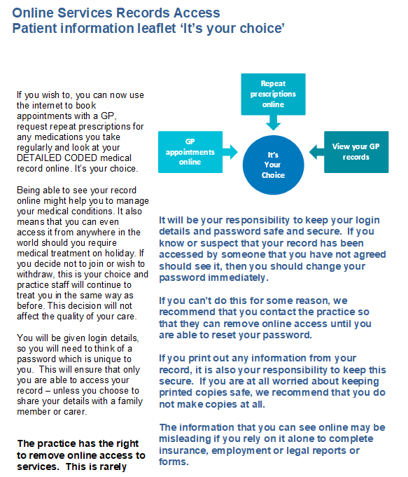
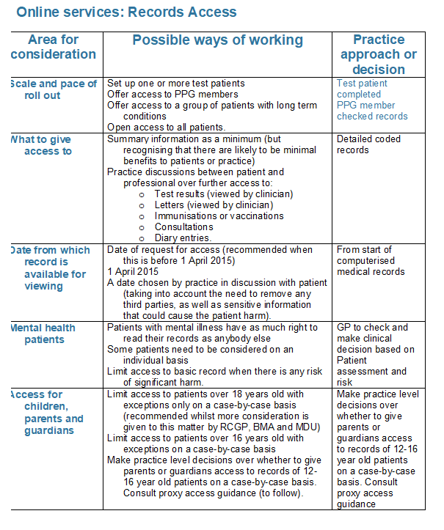

Appendix 4 – Step by Step Guide of Patients Requesting Online Detailed Coded Records
STEP BY STEP GUIDE
PATIENTS REQUESTING ACCESS TO THEIR ONLINE DETAILED CODED RECORDS

- The patient will make the request to access their medical records online.
The option to request this will be on their existing log in, in the same way they can request a repeat prescription.

- The online request will automatically create a task which will go to Julie’s inbox.

- Julie will then create a letter to the patient, explaining the procedure and the requirements for such access. An information leaflet and application form will be enclosed with the letter.
The letter explains that although the patient will have already provided us with ID when they initially registered for online services, they will need to provide this information again for security purposes.

- The patient would then bring in to the surgery, or post, the completed application, together with the requested ID. Please check all detailed are completed correctly. Please look out that all the 1-6 tick boxes have been acknowledged and that the form has been signed.

- The ID will need to be photocopied and attached to the completed application form and left in the blue folder by the post tray marked ‘Detailed Coded Records’.

- Julie will take the completed forms and inform the Doctor that a request has been made. We would aim to have the request approved and switched on for online access within 21 days, although this is a guide and will be dependent on the volume of applications, together with the availability of Doctors able to consent.

**Patients enquiring about the access to Detailed Coded Medical Records would ideally need to register for online services to be approved to request these correctly to create an audit trail for us.
**We have created a ‘Proxy Access’ application form for patients wishing to give their consent to a specific person to have access on their behalf. This form would need to be requested in writing, and would be dealt with as above upon receipt.

End of Document.

Staveleigh Medical Centre
King Street
Stalybridge
SK15 2AE

t: 0161 304 8009
w: www.staveleighmedicalcentre.co.uk
e: tgccg.staveleighmedicalcentre@nhs.net
c: P89007

